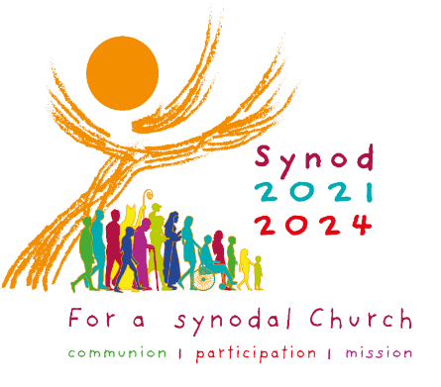
Universal Prayer Petitions for Continental Stage of the Synod of Bishops 2021-2024

You may wish to use different petitions each week.

For ourselves and all the members of the Church throughout the world: that this Synodal journey may lead us ever deeper into the communion of the Church, foster our participation in it, and equip us to go out on mission to spread the Good News of the Gospel.
In hope we pray:
Come, Lord Jesus.

For the Church as she journeys towards the Synod of Bishops 2021-2024: that our walking together as authentic companions in Christ will bear fruit in new ways of being at the service of one another.
In peace, we pray:
Come, Lord Jesus.
For a spirituality of journeying together: that we may be formed as disciples of Christ, as families, as communities, and as human beings, through our experience of this Synodal journey.
In hope we pray:
Come, Lord Jesus.

For a listening ear and a generous heart: that as a Synodal Church walking with each other, our hearts and minds be open to listening to the voice of God and to each other without prejudice.
In faith we pray:
Come, Lord Jesus.
That this Advent will be, for the Church, a faith-filled journey toward deeper
union with Christ, the prince of light and peace, and through Christ, with each
other.
In joyful hope, we pray
Come, Lord Jesus.

For a Church that celebrates: that our Synodal journey together in the coming months will be based on listening together to the Word of God and the celebration of the Eucharist.
In joyful hope, we pray
Come, Lord Jesus.
For the unity of Christians: that dialogue between Christians of different denominations, united by one Baptism, may radiate with new brightness on this Synodal journey.
In peace, we pray
Come, Lord Jesus
For our governments and community leaders: that they be inspired to lead through their committed service, be advocates for truth and justice and show compassion and understanding, especially for the most vulnerable members of our society.
In peace, we pray:
Come, Lord Jesus.

