FLOOD LIGHTING IN RED

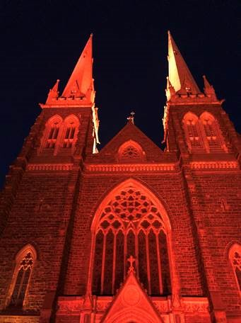
Existing lights and LED floodlights can be fitted with a red high temperature lighting gel. These red gels - which look like cellophane - can be fitted directly over existing lights and are safe to use. They do no harm or damage due to their quality.

These gels can be purchased from theatrical and lighting suppliers (however it is best to speak with your electrician in the first instance).

Alternatively, you can find a range of suppliers online by searching ‘buy high temperature lighting gel for LED floodlights in Australia’. When selecting the colour make sure you select a deep red, as this will give you the best outcome.

If there are no current floodlights, or, should you wish for an even deeper shade of red we recommend hiring some, or additional, flood lights. These can be hired from the event supply companies in your local area. Be aware that depending on the shade of your current floodlights, the red gels can sometimes come out in a very light, almost pink hue.
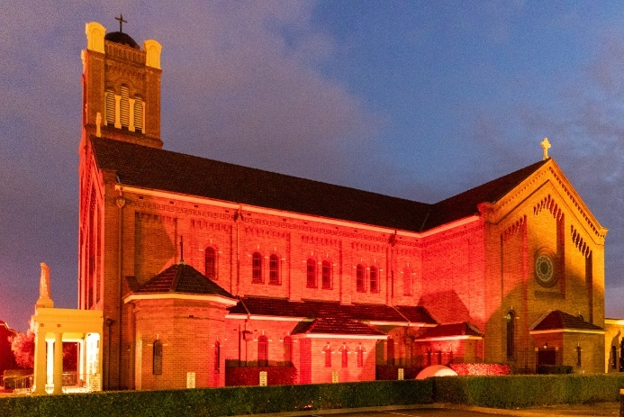
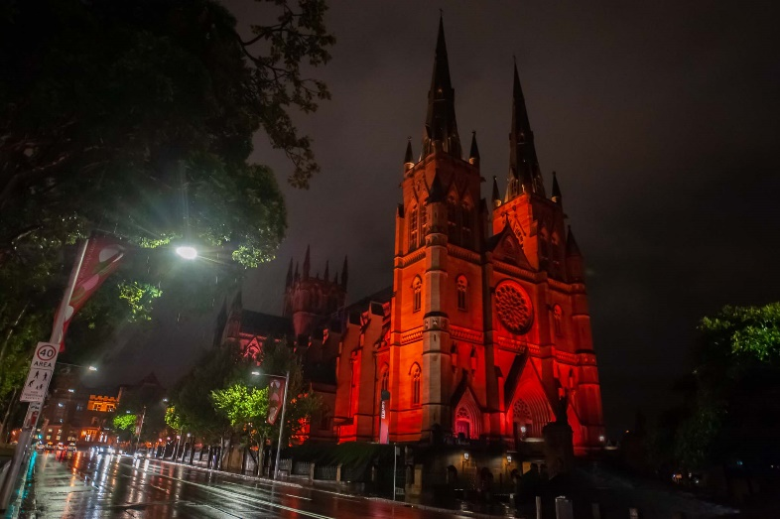
Either way, it is advisable to test the lights on a night prior to the main lighting event.

