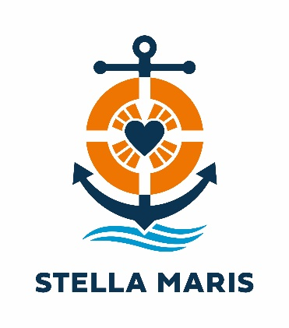

Sea Sunday – 10 July 2022
PARISH CHECKLIST

Please find Resources for Sea Sunday:
www.stellamarisaustralia.org

- Appeal Talk – please request someone to read the Appeal Talk after Communion.
- General Prayers of Intercession – please give to your Liturgy Committee representative.
- Parish Bulletin Text – please forward to the person in-charge of the Weekly Bulletin.
- Parish Checklist
- Poster – please print and stick on your parish front door or board. (Avail. A4 & A3)
- Image/s – please post on your parish Facebook page and digital Email Bulletin.
- Collections – please input details of donations to https://stellamarisaustralia.org/sea-sunday-appeal/

THANK YOU FOR YOUR SUPPORT DURING THIS ANNUAL APPEAL WHICH IS MUCH APPRECIATED.

For further information, contact: Roslyn Rajasingam
M: 0481 910 245 or E: Roslyn.Rajasingam@catholic.org.au

