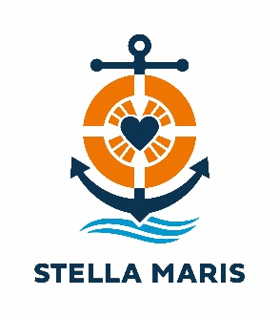

Sea Sunday – 10 July 2022

PARISH BULLETIN TEXT

For the Weekend of 2/3 July 2022:
Next week is Sea Sunday, when the church prays for all those who live and work at sea. There will be an Appeal for Stella Maris, Apostleship of the Sea, the official maritime welfare agency of the Catholic Church. Funds collected will be used to provide practical and spiritual support to seafarers visiting our ports. As it is dependent on voluntary donations, please give generously. To donate or for more information about its work, visit: www.stellamarisaustralia.org

For the Weekend of 9/10 July 2022:
Today is Sea Sunday, when the church prays for all those who live and work at sea. Without them, we would not have most of the items we rely on for daily living. Even during a pandemic, seafarers continue to bring into our ports products that sustain our population and economy.
The Appeal today is for Stella Maris, Apostleship of the Sea, the official maritime welfare agency of the Catholic Church. It supports seafarers both practically and spiritually. To assist this ministry, please send your donations to: https://stellamarisaustralia.org/sea-sunday-appeal/

