CELEBRATING
LAUDATO SI’
SUNDAY 2022

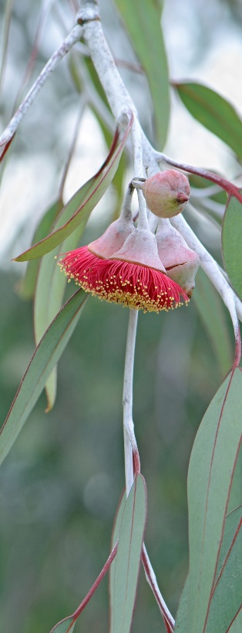
Sixth Sunday of Easter

Let the peoples praise you, O God:
Let all the peoples praise you.
May God still give us his blessing
Till the ends of the earth revere him.

The Spirit will come and teach you everything.

BULLETIN NOTICE:

LAUDATO SI’ WEEK 16th – 24th May is a global celebration where we remember Pope Francis urging us in his encyclical Laudato Si’ to hear the cry of the earth and the cry of the poor and to humbly place ourselves in communion with our common home. Today, as a Catholic Earthcare Parish we celebrate our part in the great progress the whole Church is making on its journey towards the seven Laudato Si’ Goals set before us by Pope Francis to achieve ecological conversion.

LITURGY NOTES:

INTRODUCTION:

We gather today as sisters and brothers and with all of creation.
Today, as the universal Church honours Laudato Si Week, we remember Pope Francis urging in his encyclical Laudato Si’ to hear the cry of the earth and the cry of the poor and to humbly place ourselves in communion with our common home.
Today, as a Catholic Earthcare Parish we celebrate our part in the great progress the whole Church is making on its journey towards the seven Laudato Si’ Goals set before us by Pope Francis to achieve ecological conversion.

ENTRANCE PROCESSION:

Incorporate symbols of creation into the Opening Procession e.g a globe, basket of food/flowers from people’s gardens.
e.g. In previous weeks’ bulletins, ask people to bring a plant cutting approx 20 cm – either a bloom or simply leaves and place in a basket at church entrance as they arrive. This basket is then carried up in the Entrance Procession.

Opening Hymn: See suggestions at the conclusion of this resource.

PENITENTIAL RITE:

- Lord, you invite us into communion with all of creation: Lord, have mercy
- Christ, we are a people longing for healing and reconciliation: Christ have mercy
- Lord, open our hearts so that we may hear the cry of the earth and the cry of the poor: Lord have mercy

PRAYERS OF THE FAITHFUL:

Presider: Let us bring our prayers to the God of all creation and accompany in prayer all those who most need God’s mercy and healing.
Reader: We pray for the church: That the Body of Christ listens attentively and responds with transformative practical action to the cry of the earth and the cry of the poor.
Let us pray to the Lord: R. Lord hear our prayer
Reader: We pray for our church and civic leaders: That all leaders respect and partner with the lived wisdom of First Nations people in actively caring for country and nurturing healthy, integrated communities.
Let us pray to the Lord: R. Lord hear our prayer
Reader: We pray for environmentally degraded parts of the earth, and for those living in poverty: That government, business, and community policies and practices at the local, national, and international level honour, reflect and protect the sacredness of all places, creatures, and people.
Let us pray to the Lord: R. Lord hear our prayer
Reader: We pray for all of us here: That we be trustworthy stewards, active protectors, and reverent carers of our earth and her people through conscious and just living.
Let us pray to the Lord: R. Lord hear our prayer
Reader: We pray for those who have died recently ……. And for those whose anniversaries occur about this time ……………..
Let us pray to the Lord: R. Lord hear our prayer
Presider: God of the universe, you are the living Word, planted deep in our hearts. Grant us the wisdom, courage, and commitment to love and care for your magnificent world of never-ending wonders. Direct our ideas, discernment, and action so that all can fulfil their sacred promise and purpose, according to your law. We ask this through Christ, Our Lord. Amen.

SECOND COLLECTION:

Host a second collection for solar panels for the church or for initiatives of the parish Laudato Si’ group/green team.

Eucharistic Prayer: We suggest Eucharistic prayer number 3.

REFLECTION AFTER COMMUNION choose one
- Laudato Si’ Animation CAFOD https://www.youtube.com/watch?v=o3Lz7dmn1eM (CAFOD is the British Caritas) Video is produced for children but we have had parish feedback that it’s a useful, simple introduction for adults to the encyclical – 5 mins 55 secs
- Prayer for the Earth from Laudato Si’ (video) https://www.ecojesuit.com/prayer-for-the-earth-video-from-laudato-si/ Scroll down to find Video version of Pope Francis Prayer, printed at the end of Laudato Si,’ accompanied by beautiful images – 1 min 30 secs

- Pope Francis' A Prayer For Our Earth | CAFOD https://www.youtube.com/watch?v=jaTJF1AkwcA Same prayer as above but simplified words – again accompanied by beautiful images - 2 mins 5 secs

At the CONCLUSION OF MASS, you might consider praying together (on Bulletin or data projector) one of the final prayers from Laudato Si’, such as “A Prayer for our Earth,” unless already shown in video/s above.

A Prayer for our Earth

All-powerful God, you are present in the whole universe
and in the smallest of your creatures.
You embrace with your tenderness all that exists.
Pour out upon us the power of your love, that we may protect life and beauty.
Fill us with peace, that we may live as brothers and sisters, harming no one.
O God of the poor, help us to rescue the abandoned and forgotten of this earth,
so precious in your eyes.
Bring healing to our lives, that we may protect the world and not prey on it,
that we may sow beauty, not pollution and destruction.
Touch the hearts of those who look only for gain at the expense of the poor and the earth.
Teach us to discover the worth of each thing, to be filled with awe and contemplation,
to recognize that we are profoundly united with every creature
as we journey towards your infinite light.
We thank you for being with us each day.
Encourage us, we pray, in our struggle for justice, love and peace.
AMEN Pope Francis Laudato Si’

Suggested hymns:

All Creatures of Our God & King – Gather 395
All the ends of the earth - Bob Dufford
All Things Bright and Beautiful
All you works of God - Marty Haugen
Canticle of Creation – Dan Schutte
Canticle of the Sun - Marty Haugen
For the Fruits of This Creation – Gather 426
For the Healing of the Nations – Gather 513
How Great Thou Art
Let All the Earth Their Voices Raise
Let the Heavens Be Glad
Let the Whole Creation Cry
Many and Great, O God, Are Your Works
Morning Has Broken – Gather 537
O God Beyond All Praising

